CSA1708 – ARTIFICIAL INTELLIGENCE LAB EXPERIMENTS

Experiment 17: Sum of Integers from 1 to N
Aim:
To write and execute a Prolog program to calculate the sum of integers from 1 to N.
Algorithm:
- Start the program.
- Define the base case: the sum of 0 is 0.
- If N is greater than 0, subtract 1 from N.
- Recursively calculate the sum of the previous integers.
- Add N to the previous sum.
- Display the final sum.
- Stop the program.

Program:
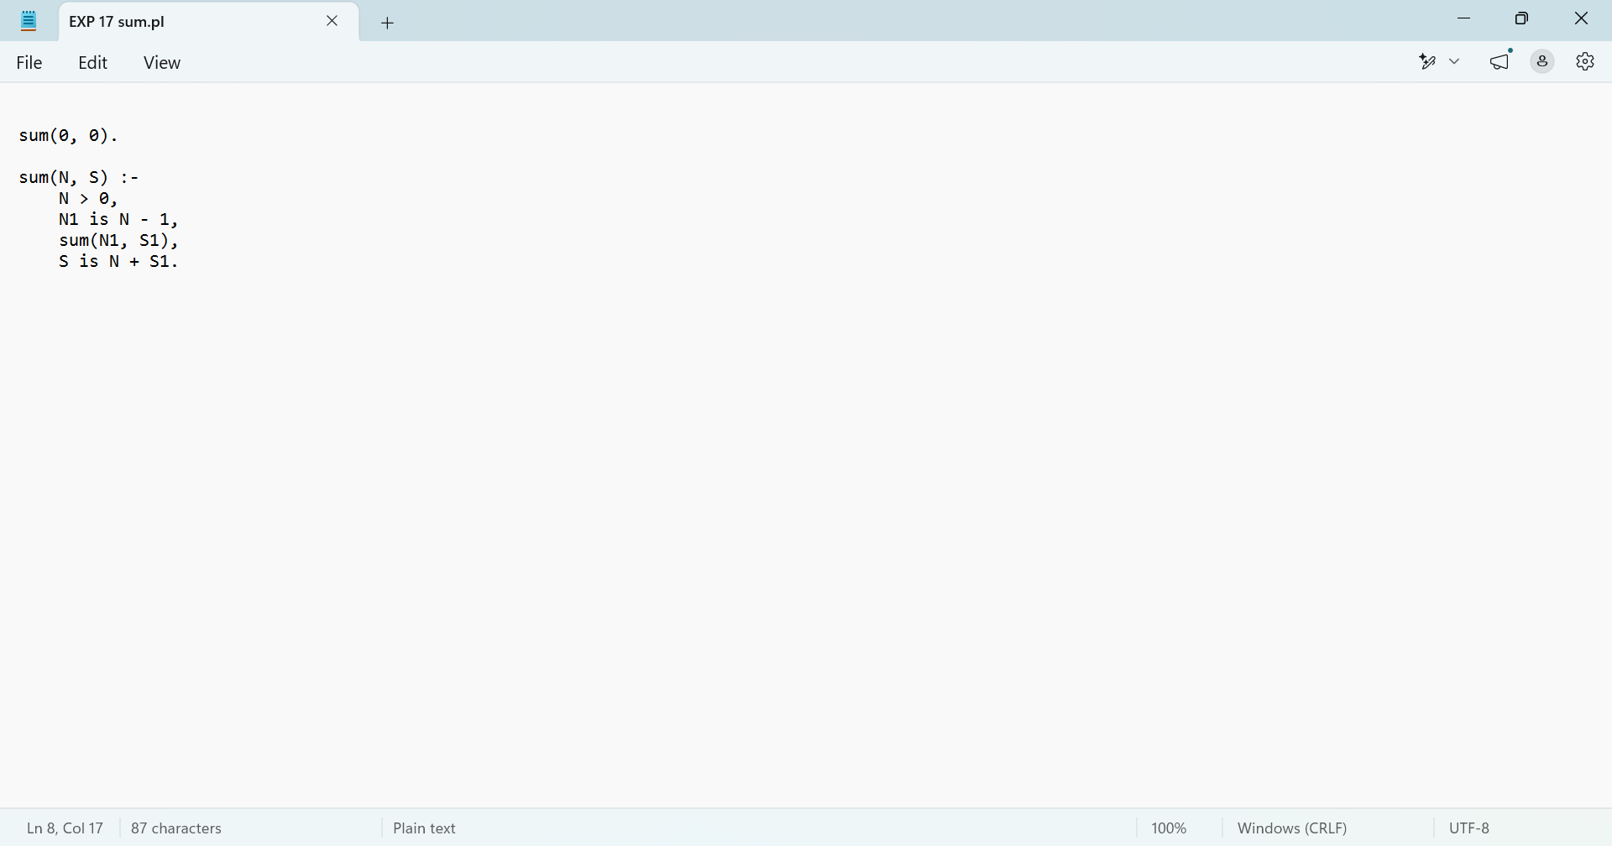

Output:
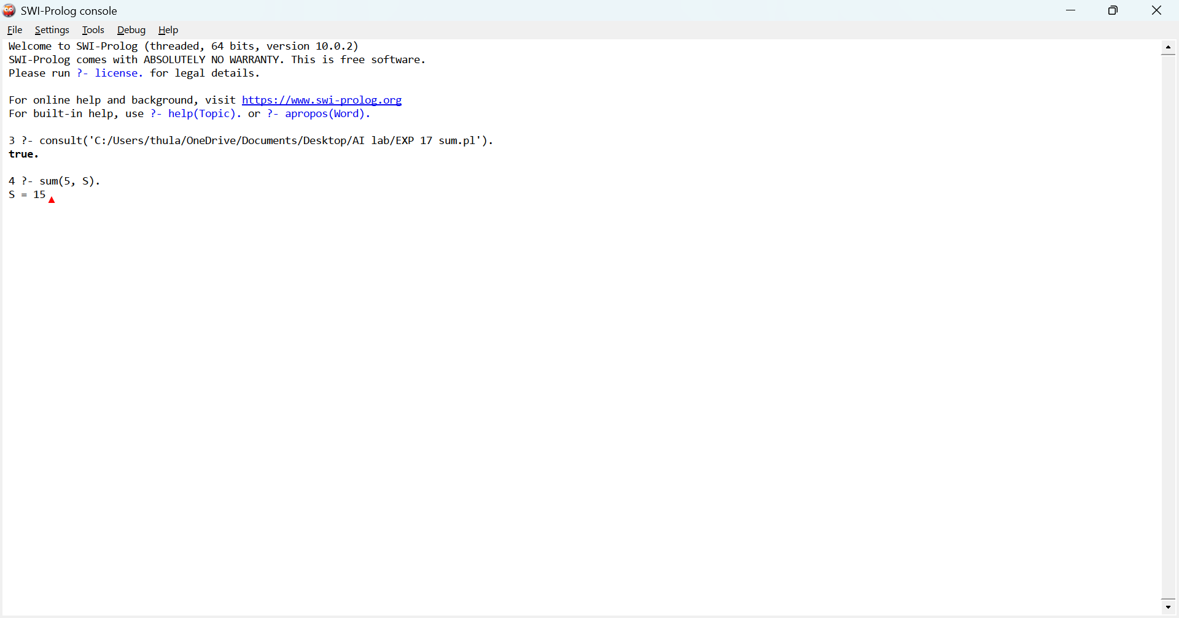

Result:
Thus, the Prolog program to calculate the sum of integers from 1 to N was successfully executed, and the output was obtained.

Experiment 18: Prolog Program for a Database with Name and DOB
Aim:
To write and execute a Prolog program to create a database containing names and dates of birth (DOB) and retrieve the details using queries.
Algorithm:
- Start the program.
- Define facts containing each person's name and date of birth.
- Load the program into SWI-Prolog.
- Execute a query to retrieve the name and DOB.
- Display the results.
- Stop the program.
Program:
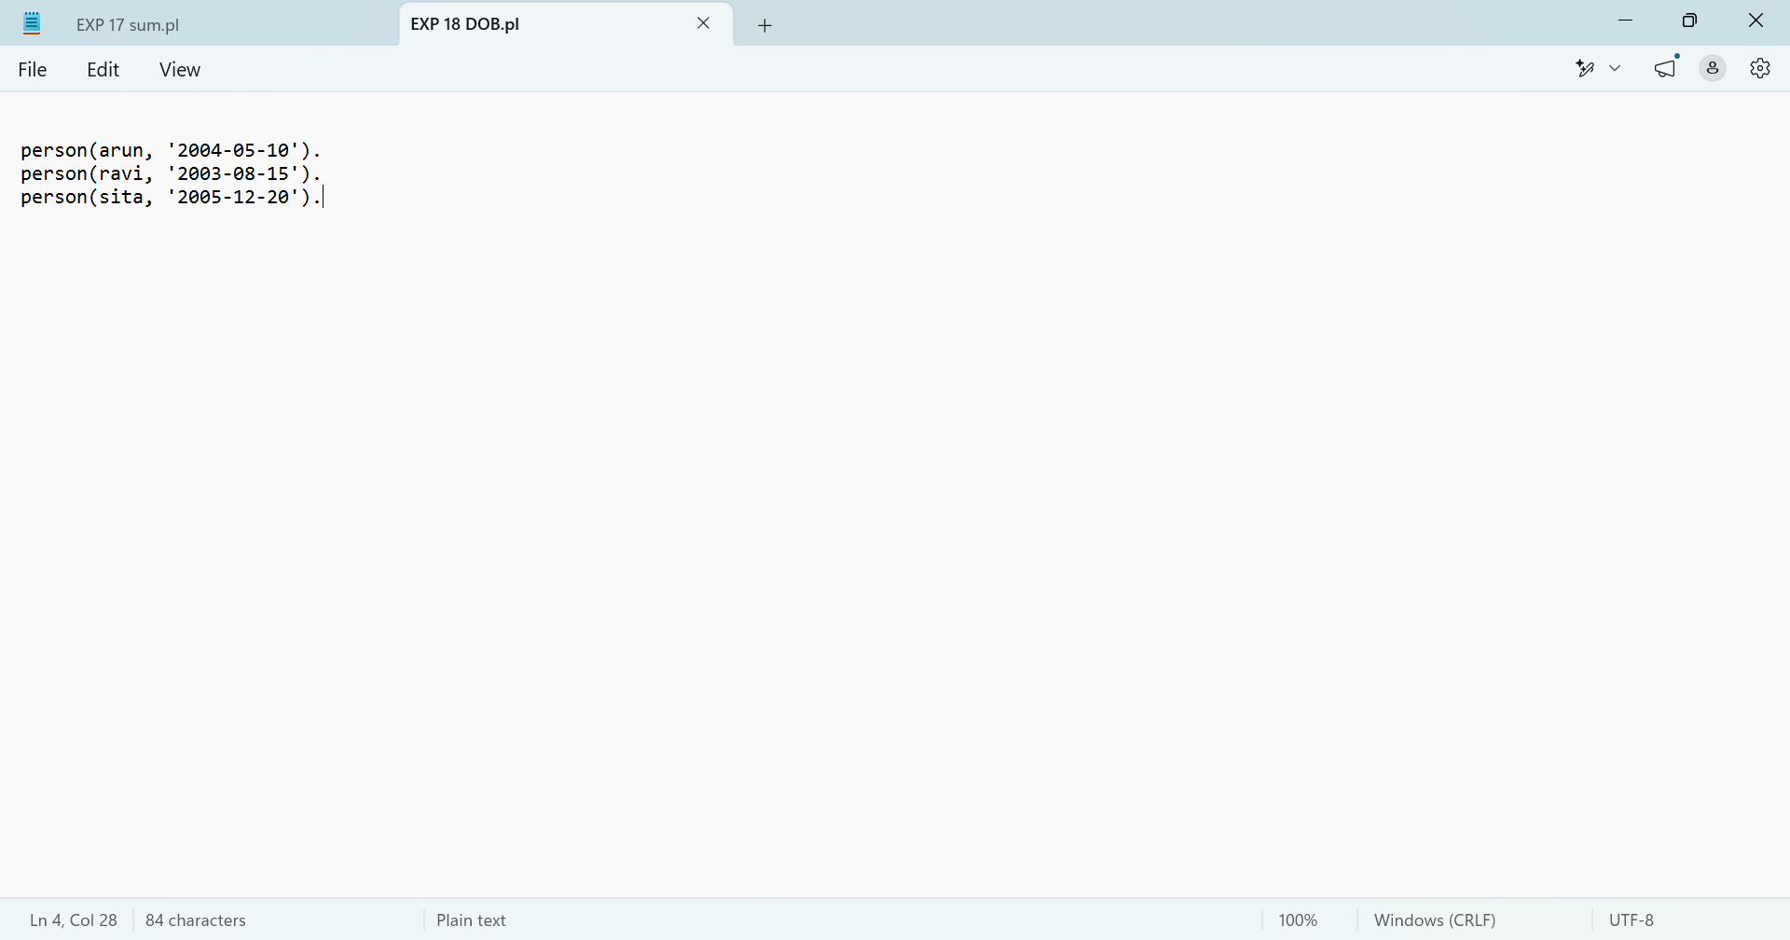

Output
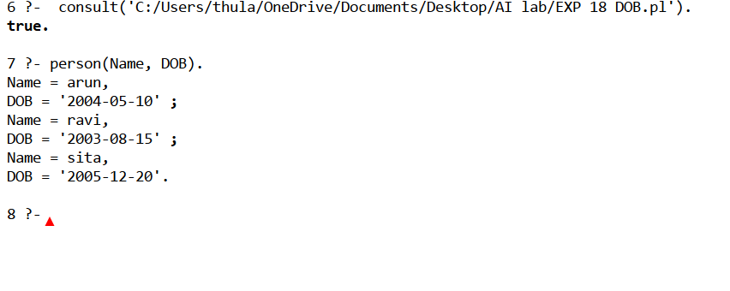

Result:
Thus, the Prolog program to create a database containing names and dates of birth and retrieve the details was successfully executed.

Experiment 19: Student–Teacher–Subject Code
Aim:
To write and execute a Prolog program to store and retrieve student names, teacher names, and subject codes.
Algorithm:
- Start the program.
- Define facts containing student names, teacher names, and subject codes.
- Load the program into SWI-Prolog.
- Execute a query to retrieve the details.
- Display the results.
- Stop the program.
Program:

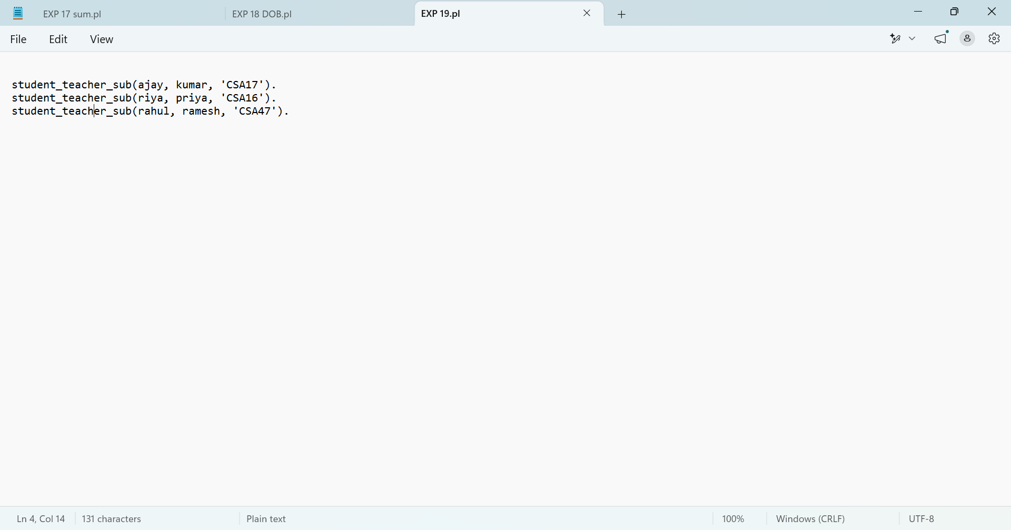

Output:
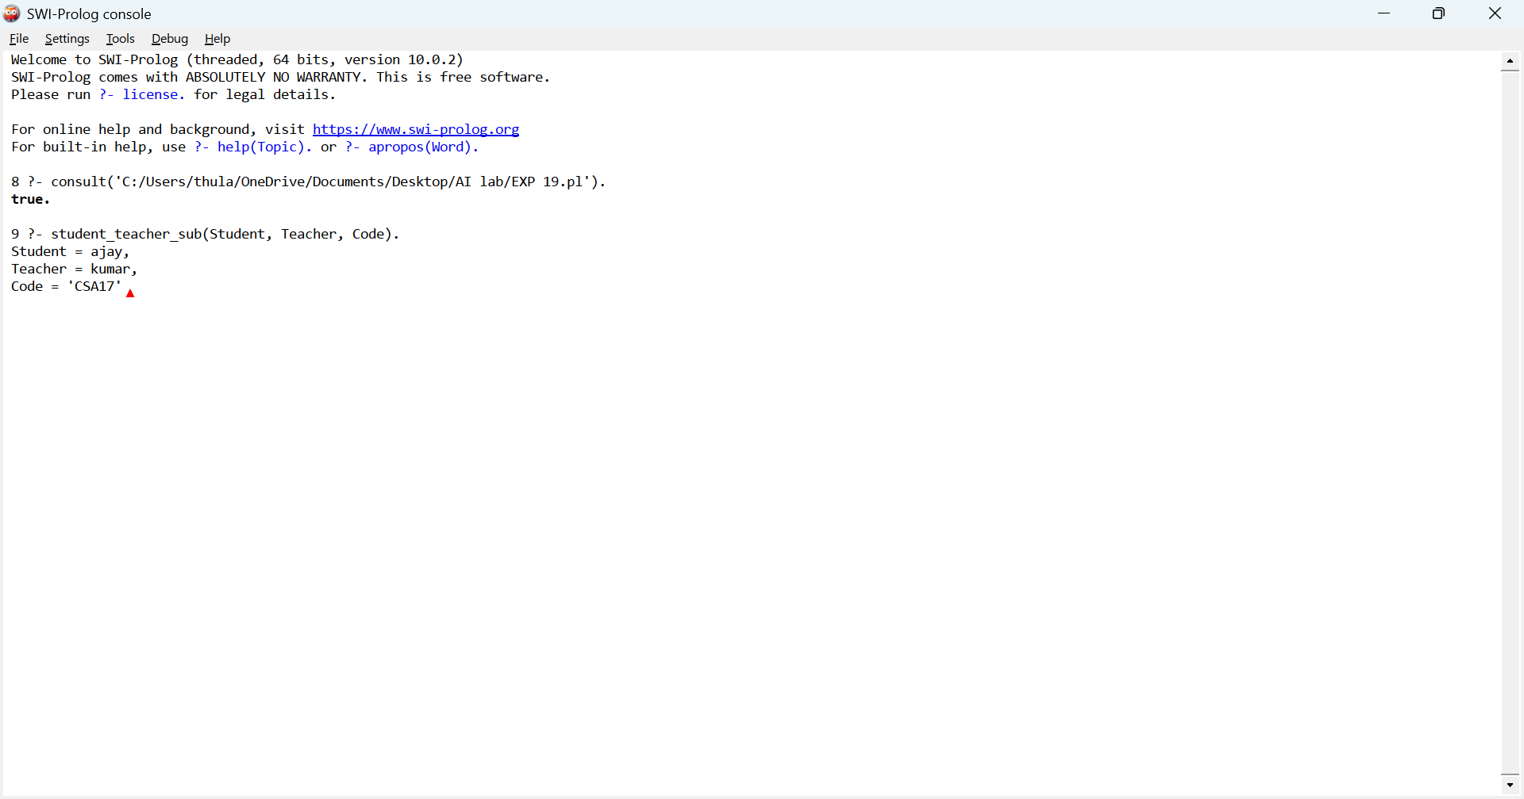

Result:
Thus, the Prolog program to store and retrieve student, teacher, and subject code details was successfully executed.

Experiment 20: Prolog Program for Planets Database
Aim:
To write and execute a Prolog program to create a database of planets and retrieve their details.
Algorithm:
- Start the program.
- Define facts containing the names of planets.
- Load the program into SWI-Prolog.
- Execute a query to retrieve the planet names.
- Display the output.
- Stop the program.
Program
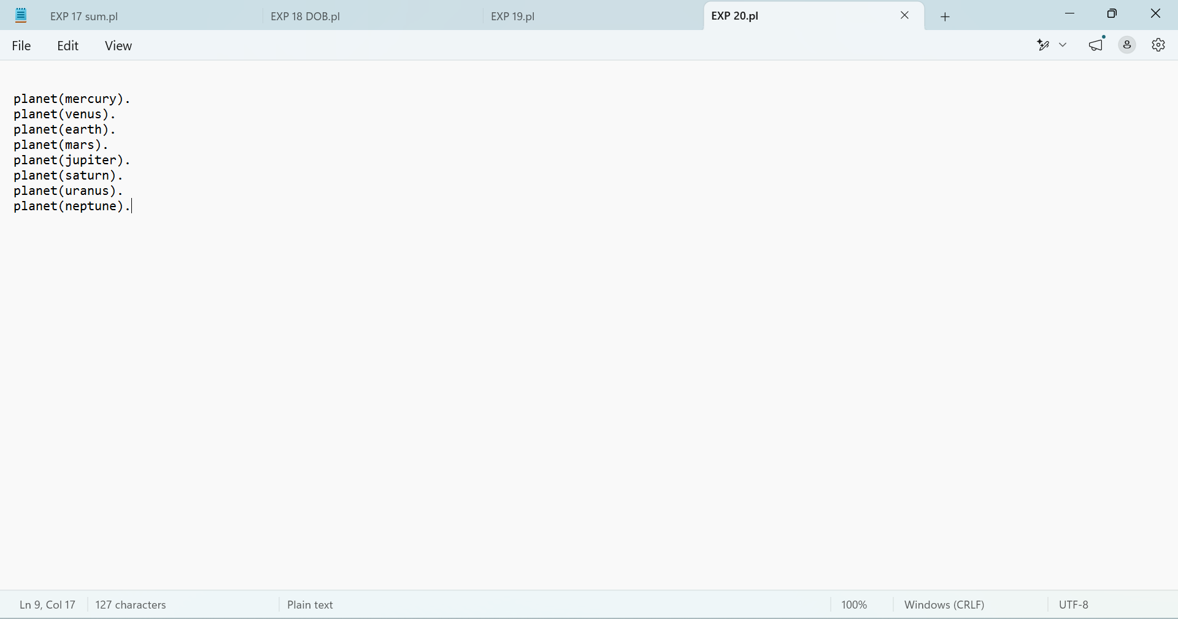

Output
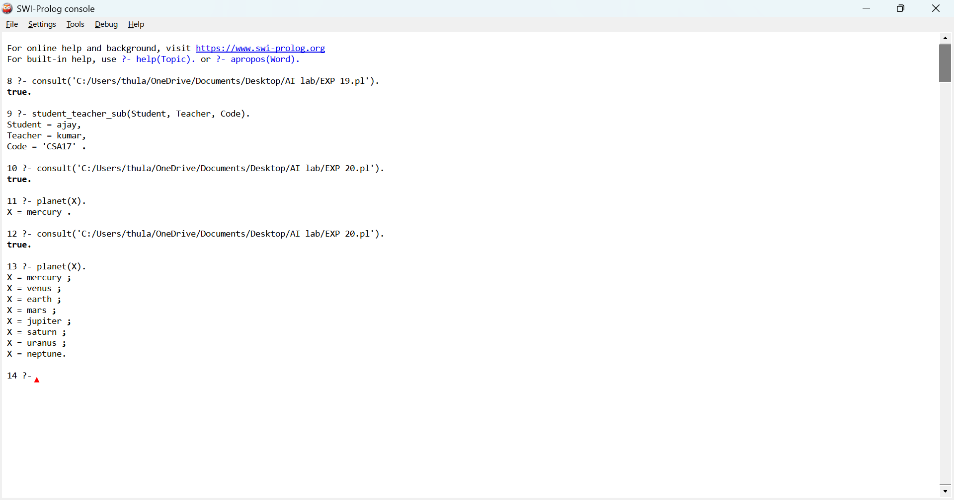

Result
Thus, the Prolog program to create a planets database and retrieve the planet names was successfully executed.

